Project management

*What Is a Project?*

* A **project** is “a temporary endeavor undertaken to create a unique product, service, or result”
* Projects end when their objectives have been reached or the project has been terminated
  + **Program**: group of related projects managed in a coordinated way to obtain benefits and control not available from managing them individually

Project Life Cycle

* A **project life cycle** is a collection of project phases that defines
* what work will be performed in each phase
* what deliverables will be produced and when
* who is involved in each phase, and
* how management will control and approve work produced in each phase
* A **deliverable** is a product or service produced or provided as part of a project

Project Phases

* Project phases vary by project or industry, but some general phases include

Concept, Development, Implementation, Close-out

Products also have life cycles

* The Systems Development Life Cycle (SDLC) is a framework for describing the phases involved in developing and maintaining information systems
* Systems development projects can follow
  + predictive models: the scope of the project can be clearly articulated and the schedule and cost can be predicted
  + adaptive models: projects are mission driven and component based, using time-based cycles to meet target dates

*What Helps Projects Succeed?*

* Experienced project manager
* Proper planning
* Reliable estimates
* Clear business objectives
* Minimized scope
* Executive support
* User involvement
* Formal methodology
* Firm basic requirements
* Competent staff

*What is Project Management?*

* 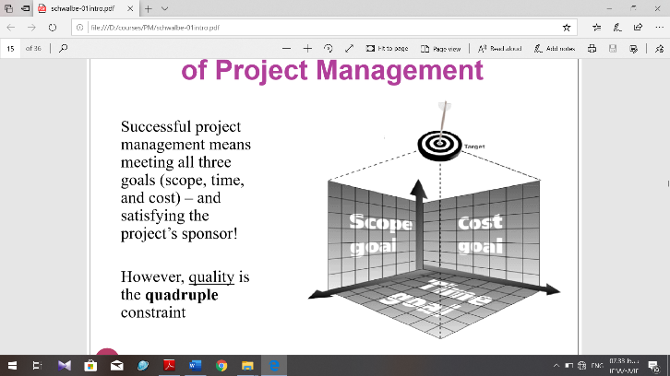Project management is “the application of knowledge, skills, tools and techniques to project activities to meet project requirements”
* Project managers strive to meet the triple constraint by balancing project scope, time, and cost goals

Project manager

A project manager can have many different job descriptions, which can vary tremendously

based on the organization and the project. In fact, PMI includes a page on their website to23

answer the question, “Who are project managers?” In addition to saying that project managers

are organized, passionate, and goal-oriented individuals who drive business results

by leading projects, PMI emphasizes that they are also change agents who work well under

pressure and enjoy challenging work environments.

*Ten Most Important Skills and Competencies for Project Managers*

1. Ethical behavior
2. People skills
3. Strong at building trust
4. Strong at building teams
5. Leadership
6. Verbal communication
7. Listening
8. Conflict resolution, conflict management
9. Critical thinking, problem solving
10. Understands, balances priorities

*Project Stakeholders*

* **Stakeholders** are the people involved in or affected by project activities
* Stakeholders include:
  + The project sponsor
  + The project manager
  + The project team
  + Support staff
  + Customers
  + Users
  + Suppliers
  + And yes -opponents to the project!

*Suggested Skills for Project Managers*

* The Project Management Body of Knowledge
* General management knowledge and skills
* Project environment knowledge
* Application area knowledge, standards, and regulations
* Soft skills or human relations skills

*Different Skills Needed in Different Situations*

* Large projects: leadership, relevant prior experience, planning, people skills, verbal communication, and teambuilding skills are most important
* High uncertainty projects: risk management, expectation management, leadership, people skills, and planning skills are most important
* Very novel projects: leadership, people skills, having vision and goals, self-confidence, expectations management, and listening skills are most important

*Distinguishing Project Life Cycles and Product Life Cycles*

* The project life cycle applies to all projects, regardless of the products being produced
* Product life cycle models vary considerably based on the nature of the product
* Project management is done in all of the product life cycle phases

